**Day 03: Class Exercise Lab**:

**Task 01: Create and Replay**

Step 01: Record the below step

* Open the Page: <https://demo.opencart.com/>
* Click on the Desktop -🡪 Mac

Step 02: Replay the recorded Script.

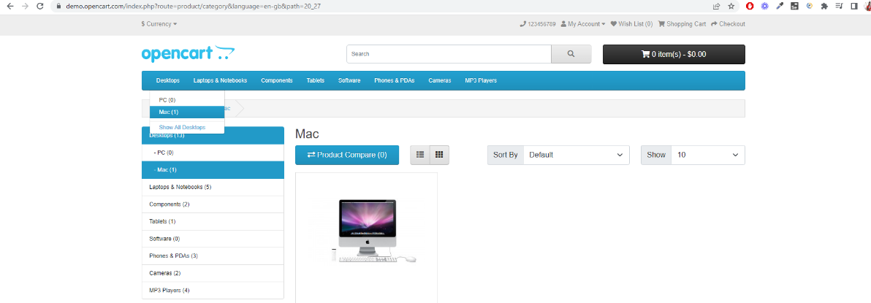

**Task 02: Selenese Commands**

Step 01: Record the below steps.

* + Open the Page: <https://demo.opencart.com/>
  + Click on the Phones & PDAs
  + Click on HTC Touch HD
  + Extract the Text “HTC Touch HD” from the loaded page and store it in the variable.

Step 02: Replay the recorded Script and print the stored Variable.

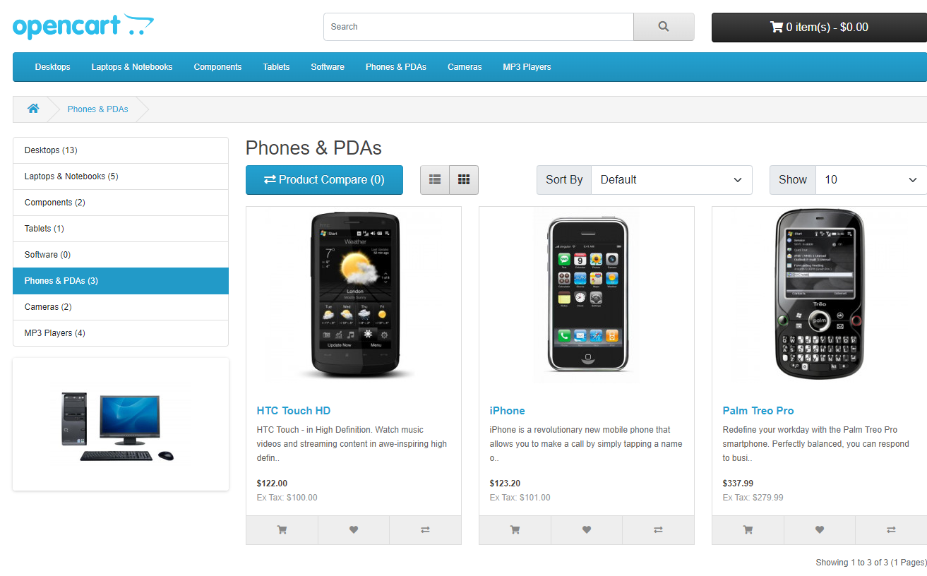

**Task 03: Selenese Commands**

Step 01: Record the below steps.

* + Open the Page: <https://demo.opencart.com/>
  + Store the Title and URL of the Page
  + Use Assert method to check the expected URL, Title and Actual Value are same.

Step 02: Replay the recorded Script.

**Task 04: Selenese Commands**

Step 01: Record the below steps.

* + Open the Page: <https://demo.opencart.com/>
  + Click on the Phones & PDAs
  + Click on HTC Touch HD and click on add to cart.
  + Use Assert method to confirm that the product is successfully added to the cart.

Step 02: Replay the recorded Script.

**Task 05: Selenese Commands**

Step 01: Record the below steps.

* + Open the Page: <https://demo.opencart.com/index.php?route=checkout/voucher&language=en-gb>
  + Assert the Value of the amount is 1.
  + Verify the text “I understand that gift certificates are non-refundable”.

